**Assignment -3**

|  |  |
| --- | --- |
| Student Name | Vimalraj T |
| Student Roll Number | 612719104071 |
| Maximum Marks | 2 Marks |

**Questions:**

1.Create a Bucket in IBM object storage.

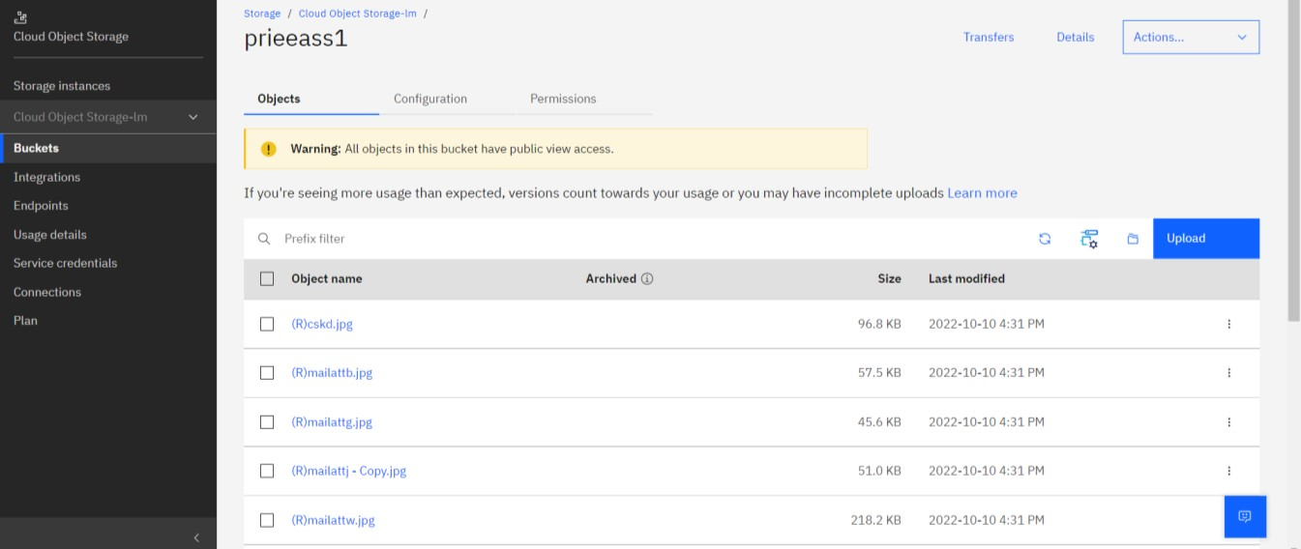

2.Upload an 5 images to ibm object storage and make it public. write html code to displaying all the 5 images.

3.Upload a css page to the object storage and use the same page in your HTML code.

**Html File for displaying images from Cloud Storage:**

*<html>*

*<head>*

*<link rel="stylesheet" href="https://s3.jp-tok.cloud-objecttorage.appdomain.cloud/prieeass1/styles.css">*

*<title>Object Storage to HTML - Assignment 3</title>*

*</head>*

*<body>*

*<main>*

*<section id="img1" class="full-section">*

*Image-1*

*<div class="img-container">*

*<img src="https://s3.jp-tok.cloud-object-storage.appdomain.cloud/prieeass1/1.jpeg" alt="Image 1" width="900"> </div>*

*</section>*

*<section id="img2" class="full-section">*

*Image-2*

*<div class="img-container">*

*<img src="https://s3.jp-tok.cloud-object-storage.appdomain.cloud/prieeass1/2.jpeg" alt="Image 2" width="900"> </div>*

*</section>*

*<section id="img3" class="full-section">*

*Image-3*

*<div class="img-container">*

*<img src="https://s3.jp-tok.cloud-object-storage.appdomain.cloud/prieeass1/3.jpeg" alt="Image 3" width="900"> </div>*

*</section>*

*<section id="img4" class="full-section">*

*Image-4*

*<div class="img-container">*

*<img src="https://s3.jp-tok.cloud-object-storage.appdomain.cloud/prieeass1/4.jpeg" alt="Image 4" width="900"> </div>*

*</section>*

*<section id="img5" class="full-section">*

*Image-5*

*<div class="img-container">*

*<img src="https://s3.jp-tok.cloud-object-storage.appdomain.cloud/prieeass1/5.jpeg" alt="Image 5" width="900">*

*</div>*

*</section>*

*</main> </body>*

*</html>*

**CSS File:**

*\* { border: 0; padding: 0; margin: 0; box-sizing: border-box; font-family: "Brandon Text, Arial";*

*}*

*main { margin-top: 60px; padding: 30px; display: flex; justify-content: center;*

*}*

*.container { width: 70%; padding: 20px; background-color: #eef;*

*}*

*.container-heading { padding-block-end: 5px; border-bottom: 5px solid black; margin-bottom: 10px;*

*}*

*.container-text { margin-block: 5px;*

*}*

**Output:**

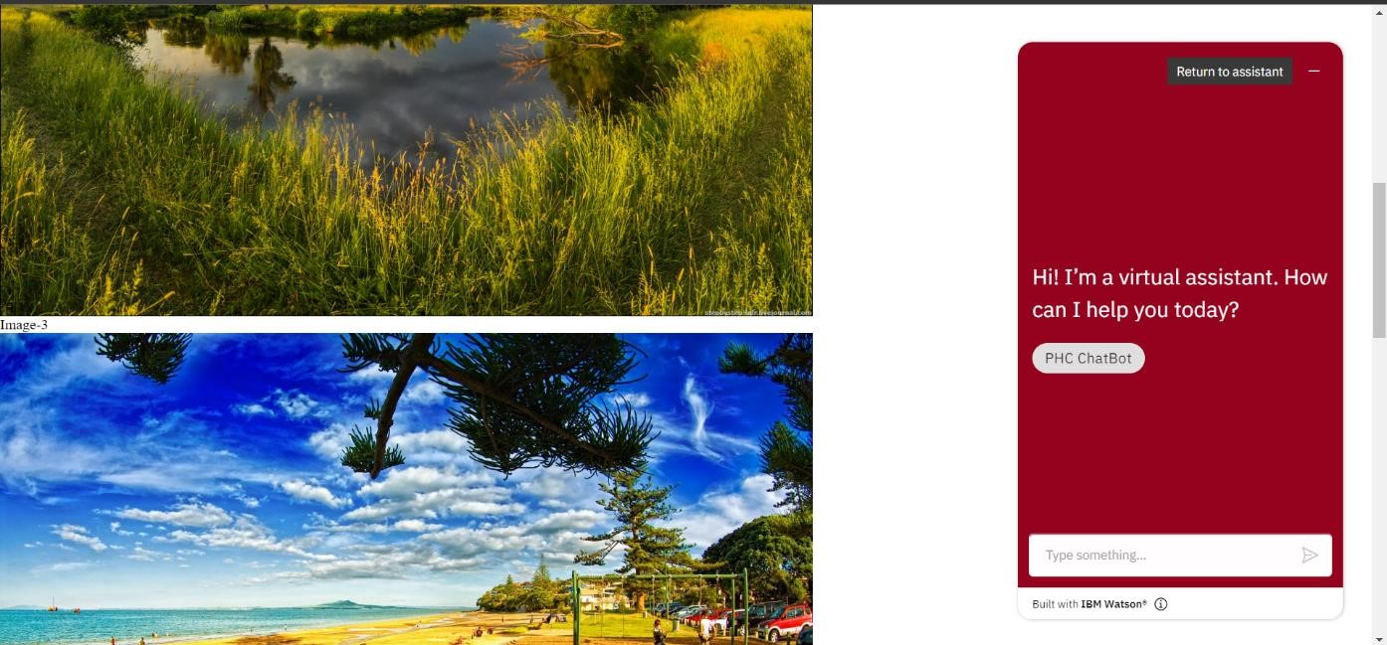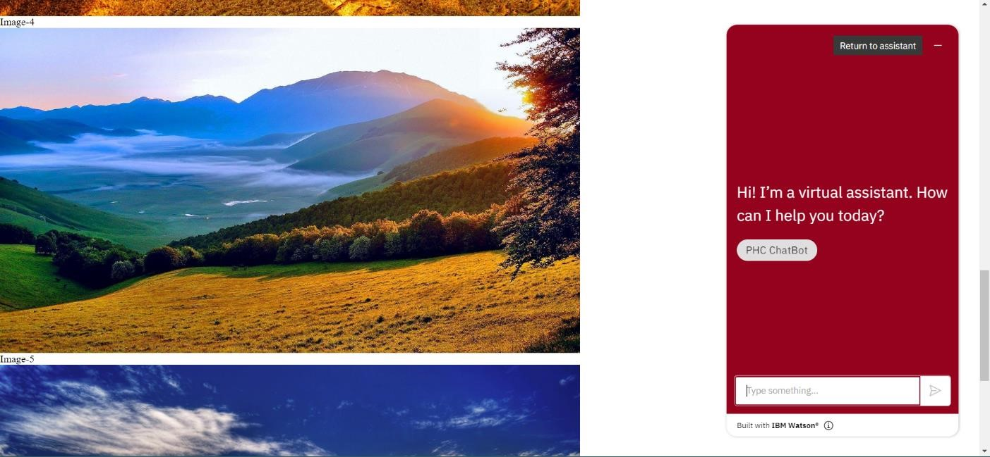

4.Design a chatbot using IBM Watson assistant for hospital. Ex: User comes with query to know the branches for that hospital in your city. Submit the web URL of that chat bot as a assignment.

[https://web-](https://web-chat.global.assistant.watson.appdomain.cloud/preview.html?backgroundImageURL=https%3A%2F%2Fus-south.assistant.watson.cloud.ibm.com%2Fpublic%2Fimages%2Fupx-009a5aaa-148c-4708-8fa2-ce7e287f5bc9%3A%3A786b3e8c-3dba-4a84-b4ae-31bca3e85710&integrationID=eb2259f3-2f07-4f26-9490-245b15cec951&region=us-south&serviceInstanceID=009a5aaa-148c-4708-8fa2-ce7e287f5bc9)

[chat.global.assistant.watson.appdomain.cloud/preview.html?backgroundImageURL=https%3A%2F% 2Fus-south.assistant.watson.cloud.ibm.com%2Fpublic%2Fimages%2Fupx-009a5aaa-148c-4708-8fa2ce7e287f5bc9%3A%3A786b3e8c-3dba-4a84-b4ae-31bca3e85710&integrationID=eb2259f3-2f074f26-9490-245b15cec951&region=us-south&serviceInstanceID=009a5aaa-148c-4708-8fa2ce7e287f5bc9](https://web-chat.global.assistant.watson.appdomain.cloud/preview.html?backgroundImageURL=https%3A%2F%2Fus-south.assistant.watson.cloud.ibm.com%2Fpublic%2Fimages%2Fupx-009a5aaa-148c-4708-8fa2-ce7e287f5bc9%3A%3A786b3e8c-3dba-4a84-b4ae-31bca3e85710&integrationID=eb2259f3-2f07-4f26-9490-245b15cec951&region=us-south&serviceInstanceID=009a5aaa-148c-4708-8fa2-ce7e287f5bc9)

5.Create Watson assistant service with 10 steps and use 3 conditions in it. Load that script in HTML page.

**Output:**

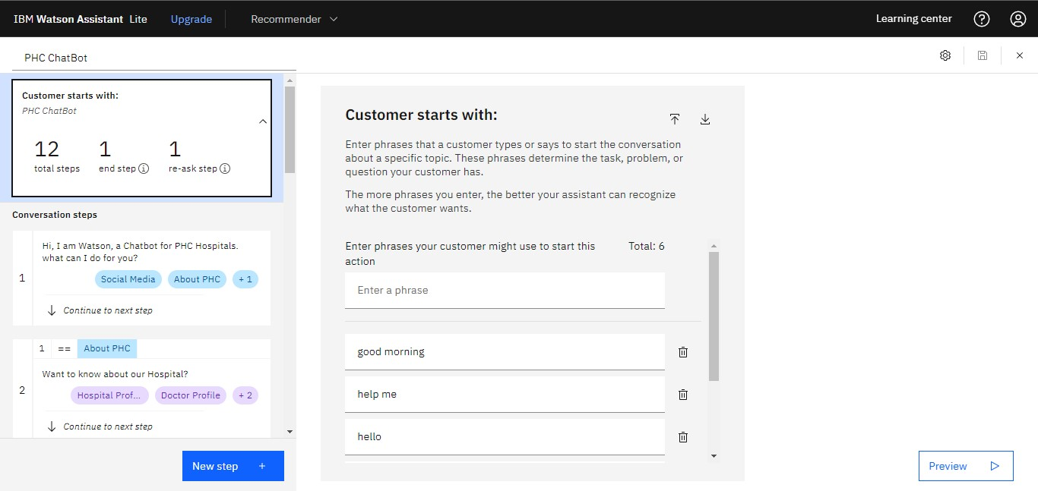

**Html File for displaying IBM Watson Chatbot:**

<script> window.watsonAssistantChatOptions = { integrationID: "eb2259f3-2f07-4f26-9490-245b15cec951", // The ID of this integration.

region: "us-south", // The region your integration is hosted in. serviceInstanceID: "009a5aaa-148c-4708-8fa2-ce7e287f5bc9", // The ID of your service instance.

onLoad: function(instance) { instance.render(); }

};

setTimeout(function(){ const t=document.createElement('script');

t.src="https://web-chat.global.assistant.watson.appdomain.cloud/versions/" +

(window.watsonAssistantChatOptions.clientVersion || 'latest') + "/WatsonAssistantChatEntry.js"; document.head.appendChild(t);

});

</script>